Gas Gate Valve
1. Scope
This manual covers gas gate valves with nominal sizes DN100 mm to DN300 mm and nominal pressure PN0.8 MPa, flanged-end connection, manual operation.
2. Purpose
2.1 This valve is used as an open/close device on city coal gas and natural gas pipelines.
2.2 Valve body material shall be selected based on the medium.
2.2.1 Ductile iron valves are suitable for coal gas and natural gas media.
2.3 Applicable temperature:
2.3.1 Ductile iron valves -- max. 120 C
3. Structure
3.1 The basic structure of the gas gate valve is shown in Figure 1.
3.2 Wear-resistant gaskets and packing use rubber asbestos sheet and fluoro rubber (FKM), providing reliable sealing.
4. Operation
Manual valves are operated by turning the handwheel by hand. The handwheel drives the stem upward and downward, which in turn moves the gate plate up and down to open or close the valve. The valve is equipped with an "OPEN" / "CLOSE" indicating mechanism. Rotating clockwise causes the gate plate to descend; the pointer points to "CLOSE" and the valve is closed. Rotating counter-clockwise causes the gate plate to rise; the pointer points to "OPEN" and the valve is open.
5. Storage, Maintenance, Installation, and Use
5.1 Valves shall be stored indoors in a dry and ventilated area. Both pipeline openings shall be sealed.
5.2 Valves stored long-term shall be inspected periodically; remove debris. Pay special attention to keeping the sealing faces clean to prevent damage.
5.3 Before installation, verify that the valve markings match the service requirements.
5.4 Before installation, inspect the valve bore and sealing faces; if any contaminants are present, wipe clean with a soft cloth.
5.5 Before and after installation, the pipeline must be blown clean to ensure no residual matter remains in the pipeline.
5.6 During pipeline pressure testing, an extended-handle handwheel must be used. Ensure the valve is fully closed (observe the pointer position). Clockwise rotation closes the valve; counter-clockwise rotation opens.
5.7 Valves shall be periodically drained and blown clean to prevent coking (fouling).
5.8 Valves shall be regularly lubricated (every 10 to 15 days) on sealing pairs and stem moving parts, to reduce operating torque and protect sealing pairs.
6. Possible Faults, Causes, and Resolutions -- See Table 1
Table 1 Possible Faults, Causes, and Resolutions
Possible Fault | Cause | Resolution
Packing leakage | 1. Packing has failed due to prolonged use or improper storage | 1. Replace packing
Leakage between sealing faces | 1. Sealing face contaminated with foreign matter  2. Sealing face damaged | 1. Clean foreign matter from sealing faces  2. Re-machine / repair or replace
Leakage at body-bonnet joint | 1. Connection bolts not tightened evenly  2. Flange sealing face damaged  3. Gasket fractured or failed | 1. Tighten evenly  2. Re-machine  3. Replace with new gasket
7. Warranty
The manufacturer provides warranty for valves placed into service for up to one (1) year from start of use, but no longer than eighteen (18) months from date of shipment. During the warranty period, any failures attributable to product quality will be repaired or have parts replaced at no charge.
8. Ordering Information
When ordering, please specify:
• Nominal pressure (MPa)
• Nominal size (mm)
• Face-to-face length standard
• Flange connection dimension standard
• Whether or not an oil injection device is required
• Whether or not an extended-handle handwheel assembly is required, and its dimensions

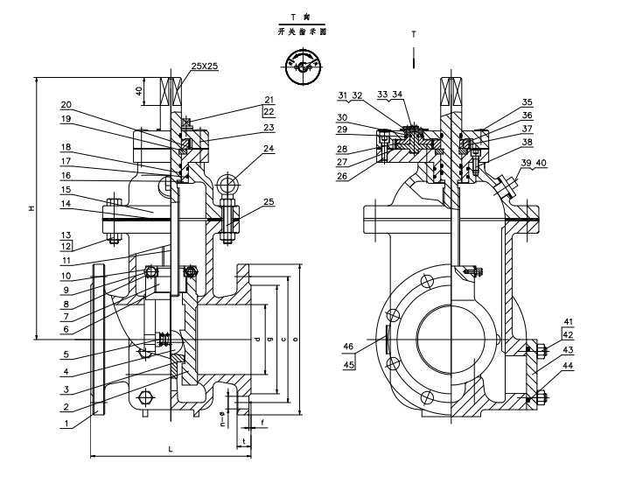
Figure 1 Manual Flanged Gas Gate Valve


WEIZIDOM GROUP
www.wsdvalves.com
South City, Longhu Town, Xinzheng City,
Zhengzhou City, Henan Province, China

